Assignment: Neural Network Architecture
Submitted By: Rajesh Kumar Sharma
Date: 13-Sep-24

Assignment: Create a neural network architecture, you can choose regression/ classification, there should be a minimum of 2 hidden layers and minimum 5 neurons in each hidden layer. Also, write down the formula to update each weight using chain rule, back propagation.
A neural network is a network structure, by the presence of computing units(neurons) the neural network has gained the ability to compute the function. The neurons are connected with the help of edges, and it is said to have an assigned activation function and also contains the adjustable parameters. These adjustable parameters help the neural network to determine the function that needs to be computed by the network. In terms of activation function in neural networks, the higher the activation value is the greater the activation is.
Backpropagation:
In machine learning, backpropagation is an effective algorithm used to train artificial neural networks, especially in feed-forward neural networks.
Backpropagation is an iterative algorithm, that helps to minimize the cost function by determining which weights and biases should be adjusted. During every epoch, the model learns by adapting the weights and biases to minimize the loss by moving down toward the gradient of the error. Thus, it involves the two most popular optimization algorithms, such as gradient descent or stochastic gradient descent.
Computing the gradient in the backpropagation algorithm helps to minimize the cost function and it can be implemented by using the mathematical rule called chain rule from calculus to navigate through complex layers of the neural network.

Advantages of Using the Backpropagation Algorithm in Neural Networks
Backpropagation, a fundamental algorithm in training neural networks, offers several advantages that make it a preferred choice for many machine learning tasks. Here, we discuss some key advantages of using the backpropagation algorithm:
- Ease of Implementation: Backpropagation does not require prior knowledge of neural networks, making it accessible to beginners. Its straightforward nature simplifies the programming process, as it primarily involves adjusting weights based on error derivatives.
- Simplicity and Flexibility: The algorithm’s simplicity allows it to be applied to a wide range of problems and network architectures. Its flexibility makes it suitable for various scenarios, from simple feedforward networks to complex recurrent or convolutional neural networks.
- Efficiency: Backpropagation accelerates the learning process by directly updating weights based on the calculated error derivatives. This efficiency is particularly advantageous in training deep neural networks, where learning features of a function can be time-consuming.
- Generalization: Backpropagation enables neural networks to generalize well to unseen data by iteratively adjusting weights during training. This generalization ability is crucial for developing models that can make accurate predictions on new, unseen examples.
- Scalability: Backpropagation scales well with the size of the dataset and the complexity of the network. This scalability makes it suitable for large-scale machine learning tasks, where training data and network size are significant factors.

Working of Backpropagation Algorithm
The Backpropagation algorithm works by two different passes, they are:
- Forward pass
- Backward pass
How does Forward pass work?
- In forward pass, initially the input is fed into the input layer. Since the inputs are raw data, they can be used for training our neural network.
- The inputs and their corresponding weights are passed to the hidden layer. The hidden layer performs the computation on the data it receives. If there are two hidden layers in the neural network, h1 and h2, the output of h1 can be used as an input of h2. Before applying it to the activation function, the bias is added.
- To the weighted sum of inputs, the activation function is applied in the hidden layer to each of its neurons. One such activation function that is commonly used is ReLU can also be used, which is responsible for returning the input if it is positive otherwise it returns zero. By doing this so, it introduces the non-linearity to our model, which enables the network to learn the complex relationships in the data. And finally, the weighted outputs from the last hidden layer are fed into the output to compute the final prediction, this layer can also use the activation function called the softmax function which is responsible for converting the weighted outputs into probabilities for each class.
Feedforward Equations:
For each layer l (hidden or output), the forward pass is:
- Z(l) = W(l)a(l−1)+b(l), where:
  - z(l) is the weighted sum (linear combination of inputs),
  - W(l) is the weight matrix for layer l,
  - a(l−1) is the activation from the previous layer (or input),
  - b(l) is the bias term for layer l.
- Activation a(l)=f(z(l)), where f is the activation function, like ReLU, sigmoid, etc.
How does backward pass work?
In the backward pass process shows, the error is transmitted back to the network which helps the network, to improve its performance by learning and adjusting the internal weights.
To find the error generated through the process of forward pass, we can use one of the most commonly used methods called mean squared error which calculates the difference between the predicted output and desired output. The formula for mean squared error is:
Meansquarederror=(predictedoutput–actualoutput) ²
Once we have done the calculation at the output layer, we then propagate the error backward through the network, layer by layer.
The key calculation during the backward pass is determining the gradients for each weight and bias in the network. This gradient is responsible for telling us how much each weight/bias should be adjusted to minimize the error in the next forward pass. The chain rule is used iteratively to calculate this gradient efficiently.
In addition to gradient calculation, the activation function also plays a crucial role in backpropagation, it works by calculating the gradients with the help of the derivative of the activation function.
Backpropagation (Weight Update using Chain Rule)
To update the weights, we use gradient descent. The error (loss) is propagated backward through the network, adjusting the weights by computing partial derivatives.
Weight Update Rule:
Let W(l) be the weight matrix of layer l, and let the loss function be L. The update rule for a weight Wij(l)​ (the weight connecting the j-th neuron in layer l−1to the i-th neuron in layer l) is:
Wij(l) := Wij(l)​ −η (∂L​ / ∂Wij(l)​)
where:
- η is the learning rate,
- ∂L / ∂Wij(l)​ is the gradient of the loss function with respect to the weight Wij(l)​.
Using Chain Rule (Backpropagation):
The derivative ∂L / ∂Wij(l)​ is computed using the chain rule as:
∂L / ∂Wij(l) = (∂L / ∂zi(l)) ⋅ (∂zi(l) / ∂Wij(l))
- ∂zi(l) / ∂Wij(l) = aj(l−1)​, where aj(l−1)​ is the activation from the previous layer.
- ∂L / ∂zi(l)​ depends on the layer:
  - For the output layer, this derivative is related to the derivative of the loss function with respect to the output (for example, the derivative of cross-entropy or mean squared error).
  - For hidden layers, this is recursively computed using:
∂L / ∂zi(l) = ∑k ( ∂L/ ∂zk(l+1)) ⋅ (∂zk(l+1)∂ai(l)) ⋅ f′(zi(l))
where f′(zi(l) is the derivative of the activation function at layer l.
Final Weight Update Formula:
Summing up all these components:
∂L / ∂Wij(l) = δi(l)⋅aj(l−1)
where δi(l) is the error term for neuron iii in layer l, defined as:
- For the output layer:
δi(L) = (∂L / ∂ai(L)) ⋅ f′(zi(L))
- For hidden layers:
δi(l) = (∑kδk(l+1)Wki(l+1)) ⋅ f′(zi(l))
This completes the update rule and backpropagation for a neural network with two hidden layers.

Problem Statement: Have chosen a classification problem for neural network architecture.
Predict whether a customer will buy a product after browsing (binary classification: 1 for purchase, 0 for no purchase) based on features such as:
- Customer age
- Customer location
- Time spent on the website
- Previous purchases
- Pages viewed
- Loyalty program membership

Neural Network Architecture for Retail Classification
- Input Layer:
  - Let's assume we have 6 input features (e.g., customer demographics, browsing behavior).
- Hidden Layer 1:
  - 5 neurons, ReLU activation.
- Hidden Layer 2:
  - 5 neurons, ReLU activation.
- Output Layer:
  - Since this is a binary classification problem (purchase or no purchase), we will use 1 neuron with a sigmoid activation function to output a probability value between 0 and 1.

We design a fully connected feedforward neural network with the following structure:
- Input Layer: Number of neurons = Number of input features (let's assume 6 features).
- Hidden Layer 1: 5 neurons, activation function = ReLU (Rectified Linear Unit).
- Hidden Layer 2: 5 neurons, activation function = ReLU.
- Output Layer:
  - For classification (binary or multi-class): softmax or sigmoid activation function (number of neurons = number of classes).
  - For regression: linear activation function (1 neuron).
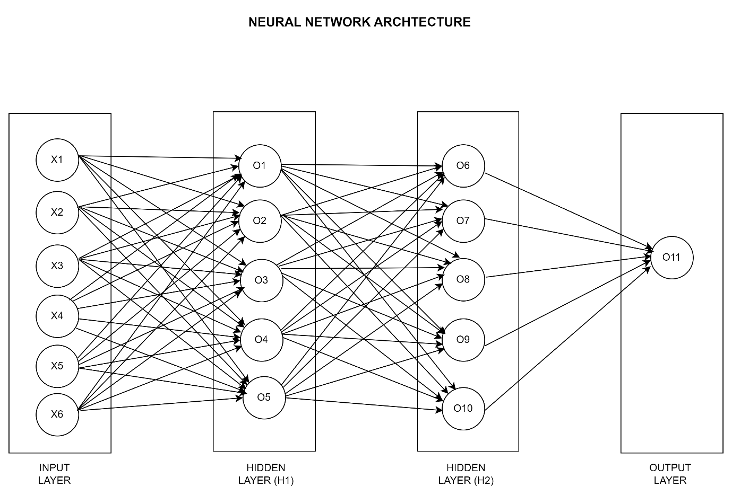

Input Features:
- Age: 28
- Time on Site: 15 minutes
- Number of items in cart: 3
- Previous purchases: 4
- Device used: Mobile (encoded as 1)
- Promo code used: Yes (encoded as 1)
These values will be fed into the neural network, which has 2 hidden layers and an output layer for a binary prediction.
Neural Network Structure with Example Values
Input Layer:
- Input features = [28, 15, 3, 4, 1, 1] (6 features total).
Hidden Layer 1 (ReLU Activation):
- Weights (randomly initialized) for each neuron in Hidden Layer 1:
  - Neuron 1: [0.2, -0.1, 0.4, 0.3, 0.5, -0.2]
  - Neuron 2: [-0.3, 0.6, -0.2, 0.1, -0.4, 0.2]
  - Neuron 3: [0.4, 0.2, -0.3, 0.5, 0.1, -0.1]
  - Neuron 4: [0.1, 0.3, -0.2, -0.4, 0.6, 0.2]
  - Neuron 5: [-0.1, 0.2, 0.5, 0.1, -0.3, 0.4]
- Biases for each neuron in Hidden Layer 1: [0.1, -0.1, 0.2, 0.3, -0.2]
- ReLU Activation:
Z₁ = W₁ * input + b₁
Applying ReLU to each neuron:
a₁ =ReLU(z₁) = [9.6,1.7,4.8,3.5,2.2]
Hidden Layer 2 (ReLU Activation):
- Weights for each neuron in Hidden Layer 2:
  - Neuron 1: [0.3, -0.2, 0.4, 0.1, 0.5]
  - Neuron 2: [-0.5, 0.6, 0.2, -0.4, 0.3]
  - Neuron 3: [0.1, -0.3, 0.5, 0.2, 0.4]
  - Neuron 4: [0.6, 0.2, -0.1, 0.3, -0.2]
  - Neuron 5: [0.2, -0.5, 0.3, 0.6, 0.1]
- Biases for each neuron in Hidden Layer 2: [0.2, -0.3, 0.1, 0.2, -0.1]
- ReLU Activation:
z₂=W₂⋅a₁+b₂
After ReLU, we get:
a₂ = [6.4,2.1,3.7,4.2,1.9]
Output Layer (Sigmoid Activation):
- Weights for the single output neuron:
W₃ = [0.4,0.5,−0.2,0.3,−0.1]
Bias for the output neuron: 0.1
- Sigmoid Activation:
z₃ = W₃ ⋅ a₂ + b₃ = 0.4×6.4+0.5×2.1−0.2×3.7+0.3×4.2−0.1×1.9 + 0.1
After calculation:
z₃ = 4.02
Applying the Sigmoid function:
a₃ = σ(z₃) = (1 / (1+e^{−4.02})) = 0.982
This means the model predicts a 98.2% chance that the customer will make a purchase.

Backward Pass (Backpropagation)
The backward pass involves using the error between the predicted output and the actual label (in this case, whether the customer made a purchase or not) to adjust the weights and biases.
1. Loss Calculation
For binary classification, we typically use binary cross-entropy as the loss function.
If the actual label (whether the customer made a purchase) is Y = 1 (indicating the customer did make a purchase), the loss function is:
Loss=−[Y log(a₃) + (1−Y)log(1−a₃)]
Substituting a₃ = 0.982 (the predicted probability):
Loss =−[1 log(0.982)+0 log(1−0.982)] = 0.018
So, the error is small because the prediction is very close to the actual label (98.2% purchase probability when the customer did purchase).
2. Backpropagation to the Output Layer
The goal is to update the weights and biases by calculating the gradient of the loss with respect to the output layer's weights and biases.
Error at Output:
The gradient of the loss with respect to z₃ (the weighted sum in the output layer) is:
δ₃ =a₃ − Y
Substitute a₃ = 0.982 and Y = 1:
δ(3)=0.982−1 = −0.018
This error term will be used to update the weights in the output layer.
Weight Update for Output Layer:
The gradient of the loss with respect to the weights in the output layer is:
∂Loss / ∂W₃ = δ₃ ⋅ a₂
For each weight W_{i3}​, we update it as:
W_{i3} = W_{i3} − η⋅∂Loss / ∂ W_{i3}
Where η is the learning rate.
Let’s assume the learning rate η=0.0. The updated weights for the output layer will be:
W₃ = [0.4,0.5,−0.2,0.3,−0.1]−0.01⋅(−0.018)⋅[6.4,2.1,3.7,4.2,1.9]
After calculating:
W₃ = [0.4012,0.5004,−0.1993,0.3008,−0.0997]
The bias in the output layer is updated similarly:
b₃ =b₃ −η⋅δ₃ = 0.1−0.01⋅(−0.018) = 0.10018

3. Backpropagation to Hidden Layer 2
Next, we propagate the error backward to Hidden Layer 2. The error term for Hidden Layer 2 is:
δ₂ = δ₃⋅W₃⋅ReLU′(z₂)
Since the derivative of ReLU is 1 for positive values of z_{2,} we calculate δ₂ as:
δ₂ = (−0.018)⋅[0.4012,0.5004,−0.1993,0.3008,−0.0997] = [-0.0072, -0.009, 0.0036, -0.0054, 0.0018]
Weight Update for Hidden Layer 2:
The weight updates for Hidden Layer 2 follow a similar formula:
∂Loss /∂W₂ = δ_{2 .} a₁
For each weight W_{i2}, the update rule is:
W_{i2} = W_{i2} − η⋅∂Loss / ∂ W_{i2} ​
Substituting values:
W_{i2} = W_{i2} − 0.01⋅δ₂⋅a₁
Let's compute for one of the neurons in the second hidden layer. Assume for Neuron 1:
W_{i2} = [0.3,−0.2,0.4,0.1,0.5]−0.01⋅(−0.0072)⋅[9.6,1.7,4.8,3.5,2.2]
After calculating:
W_{i2} = [0.3007,−0.1998,0.4003,0.1003,0.5002]
The bias for the hidden layer 2 neurons is updated similarly.
4. Backpropagation to Hidden Layer 1
Now, we propagate the error back to Hidden Layer 1. The error term for Hidden Layer 1 is:
δ₁ = δ₂⋅W₂⋅ReLU′(z₁)
The weights in Hidden Layer 1 are updated similarly using the gradients, and so are the biases.

Summary of Steps for Backpropagation:
- Loss Calculation: Compute the loss using binary cross-entropy.
- Output Layer: Calculate error, update weights and biases.
- Hidden Layer 2: Propagate the error back, update weights and biases.
- Hidden Layer 1: Propagate the error further back, update weights and biases.
- Repeat for each epoch.

